Specification and Design Report

**Student’s Name:**

**Students Number:**

**Student’s Email Address:**

**Project Title: Farmer Companion**

**DA Class ID:**

**Name of DA:**

**Name of GDI:**

**Name of SSM:**

**The Specification:**

**Background:**

Currently, small farming industries are facing a lot of ups and downs. They are unable to manage their business efficiency and productivity which as a result increase investment costs and increase hunger rate which is already on verge. Marketing trends are changing every day, and the ones which are affected the most are “Farming industry”. To help them, manage things precisely they badly need the proposed solution.

**Project Context:**

This product is designed to automate the farming industry. It is something the farming industry is craving for. Within few simple steps, it will unable every small or big farming industry to increase productivity and decrease cost. Keeping them aware of the modern tools and technologies, will help them analyse their farm in a better way. Moreover, interacting with farmers, giving them the cost effective solutions to their problems is the competitive edge of this software product. It will automate the most time investing work i-e monitoring of crops and land and will guide the easiest way outs to carry operations.

**Problem Statement:**

Current methodologies and solutions do not offer advantages to small scale industries. Collecting data and then analyse and execute it properly take ages, which gradually become the cause of the decrease in production. Another reason behind the selection of this project was the tremendous increase in hunger rate. According to exact figures population will hit over nine billion by 2050. This means we might not left with enough food to feed whole population. This requires increase in production rate over sixty percent approximately. Currently our industries lack in efficiency because of which required production rate cannot be met.

**Product Advantages:**

* Keeping them aware of Market Trends.
* Easy to use (user friendly).
* Real time updates
* 24 hour monitoring
* Intuitive
* Cost reduction
* Increase Productivity
* Increase Food Production

**Target Audience:**

Farming industry

**Ethical considerations:**

Our initial stage requires responses from farmers. There is certainly no point of making this product without their active participation. So this step required their approval. Keeping in view their considerations is very important.

As accessing data of their farms, getting it monitored cannot be done unethically without letting them know.

**Data Gathering:**

The project work will involve gathering a lot of data like:

* Currently using processes
* Investment costs
* Time
* Profits
* Losses
* Area under consideration
* Tools and equipment using till date
* Major difficulties.

**Tools/ Software to be used:**

|  |  |
| --- | --- |
| **Software** | **Task** |
| **Google Docs** | Data gathering |
| **Visual Studio** | Artefact implementation |
| **Mongo dB under MLAB** | Data storage |

**Project Flow:**

Project Proposal

Farmer Companion application that will be the farmer’s helping hand.

Research

* Gathering and Analysing data
* Defining Algorithms
* Design Model

Artefact

* Farmer Companion
* applications: API and web application

Evaluation

* Deployment
* Prototyping
* Evaluation by target audience

**Literature Survey/Review:**

A lot of work has been done previously in this regard. Highlighting few of them:

**Digital Farming:** In today’s modern era, data is considered to be the integral part. Whatever organization or industry we take, most important asset is the “data”. Thus, to manage it is also a big task. With advancement; big data analytics came into existence and is holding over every major other sector of the world. Whether it is an institution or a Google deep mind, big data analytics is everywhere. Foreseeing the advantages, scholars and writers thought of initializing it in farming industry. They were sure that “digital farm” will be a sight to watch. (Galt 2013, p. 343).

**Need of big data in Agriculture:** We should find ways to produce and distribute more food because it has been estimated that there will be an increase in population and it will result in about 9 billion people by 2025. The fact that agriculture covers about 40% of the earth’s surface is challenging. During production a lot of food is lost and wasted which affect the economy by $940 billion. All of these assumptions and estimations tell us there is a need of data efficiency in agriculture and the food industries. [2]

**Cropio:** The operations and activities associated with agriculture, user planning, remote monitoring of agricultural land, real time crop conditions and problem areas updates, analysing vegetation levels, weather forecasts, market overview are all carried out by Cropio which is a satellite based management system. [3]

**Easy Farm**: The income and expenses record, input transactions, inventories update, creation of up to date balance sheet are all done and tracked using Easy Farms which has chart of accounts synchronized with agriculture industry and provides great selection of reports. Making budgets, tracking family expenses and how it can be reduced can be done with the help of Easy Farm software. There are many pros and cons of this software. This software is not cloud based but it cannot be considered as a disadvantage because it provides us with backup facility due to which or important data is not lost even if we exit the program, or our system is shut down accidentally. Other benefits include no fee for using this software, saves the system from hacking. Easy farm provide user friendly interface it provides real time transaction update by providing with a deposit slip. It provides with technical assistance from the people who are familiar with agriculture and English language whenever you think you are stuck at some point. You are just a call away. [4]

**Tamero.com:** The software provides you with device friendly interface, manages your farm by providing real time reports on cell phones, real time update of information on all devices, provides visual environment to manage crops. Tracking and recording history, customized weather forecast for your location. All these activities are carried out using one software, which is Tambero, termed as the future of farming. [5]

**Literature Survey References:**

[1.] Galt, RE 2013, ‘The Moral Economy Is a Double-edged Sword’, Economy Geography, 89, pp. 341-365.

[2.] <https://www.talend.com/blog/2018/03/19/how-big-data-is-growing-agriculture/>

[3.] https://www.capterra.com/p/133659/Cropio/

[4.] https://www.capterra.com/p/16509/EasyFarm/

[5.] .https://www.tambero.com/farm-management-en

**The Design**

The software aims at providing an efficient interface to the user for managing their farm activities; it will provide user various options to increase their productivity. It will play a role of a

* Farmer
* Advisor
* Monitor
* Processor
* Forecaster
* Problem Solver

The respective farm will be continuously monitored against several principles and natural calamities. The design is such that the user does not have to manually keep check and balance of farm activities, the Software does it for the user.

**Software, in a picture:**

[](https://www.google.com.pk/url?sa=i&rct=j&q=&esrc=s&source=images&cd=&cad=rja&uact=8&ved=2ahUKEwizgq-m9rreAhWllYsKHfzaAb8QjRx6BAgBEAU&url=https://thenounproject.com/term/advisor/&psig=AOvVaw3_qosB3eruacv0zab3YP5O&ust=1541427294940931)[](https://www.google.com.pk/url?sa=i&rct=j&q=&esrc=s&source=images&cd=&cad=rja&uact=8&ved=2ahUKEwiakaem9breAhXjqIsKHUKJC4UQjRx6BAgBEAU&url=https://www.iconfinder.com/icons/1684303/agriculture_farm_farmer_icon&psig=AOvVaw1yKKoq5u22_99faIK59EQV&ust=1541426733779103)[](https://www.google.com.pk/url?sa=i&rct=j&q=&esrc=s&source=images&cd=&cad=rja&uact=8&ved=2ahUKEwjF-d3987reAhXFlosKHe-UDkwQjRx6BAgBEAU&url=https://www.clipartmax.com/middle/m2i8A0A0b1m2b1i8_weather-forecasting-rain-icon-cloudy-day-clip-art/&psig=AOvVaw38ml0r_f0TfJLZhF6vzF8Q&ust=1541426659678868)[](https://www.google.com.pk/url?sa=i&rct=j&q=&esrc=s&source=images&cd=&cad=rja&uact=8&ved=2ahUKEwjkvZLR87reAhXItYsKHWGCCmQQjRx6BAgBEAU&url=https://iconscout.com/icon/system-monitoring&psig=AOvVaw27O1v_MZaqsvO_aGN4alre&ust=1541426575403455)

Advisor

Monitor

Farmer

Forecaster

Farmer Companion

F

**Architectural Design:**

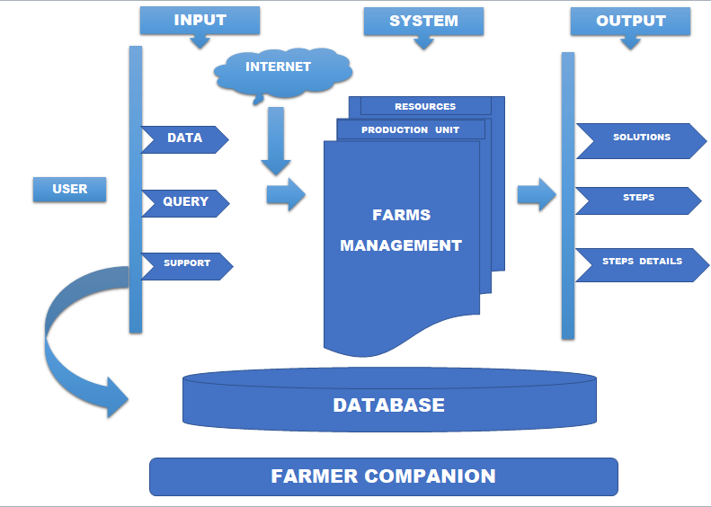

**Description:**

**User End:**

Users either asks for support from the system or gives input (enter data) that will be stored in the database.

**System End:**

Action will be taken against user query input. System will search for possible solutions in different departments like (production unit department, resources department, climate department etc. According output will be generated. It will be in form of solutions, series of steps which a user is supposed to follow.

**Flowchart:**

Start

**Wrong password**

Login

Home

Already a user

**Yes**

Make suitable choice

**Database**

Edit data

**No**

**No**

Enter Farm data

**Yes**

**Incorrect fields**

Data fields

Search for query

Select query

**Actor:**

Farmer will be the main actor of this software system.

**Framer (System Admin):**

SA performs the following functions:

1. Login
2. Manage Account
3. Add data

* Add location
* Add Climate
* Add industry type
* Add harvest season

1. Add query
2. Update data/record
3. Delete record
4. Ask for solution
5. Follow series of step

**Use Case Diagram:**

Farmer Companion



System User

**User Description:**

|  |  |
| --- | --- |
| **Use Case Name** | **Description** |
| **Login** | This operation allows farmer to access the site with authentic id. |
| **Manage Account** | This operation allows farmer to control his/her account like change password etc. |
| **Add Data** | This operation allows farmer to add data that will be processed according by the system.  For example: User will enter his location/industry details/appropriate figures |
| **Delete Data** | This operation allows farmer to delete specific entry. |
| **Update Data** | This operation allows farmer to update specific entry. Like he can change his location or want to change current profit figures etc. |
| **Add Query** | This operation allows farmer to ask for concerned problem against which he wants the solution. |
| **Ask for Solution** | After entering concerned problem, system will ask user if he wants a solution to it, user will click on it and appropriate series of steps will be displayed on the screen. |

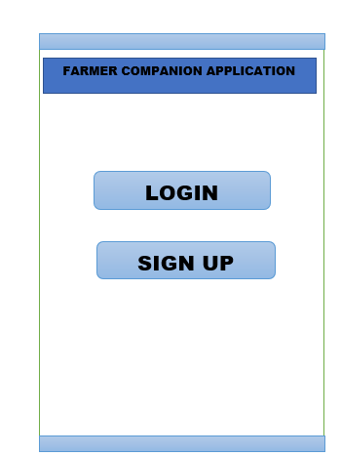**Tentative Interface:**

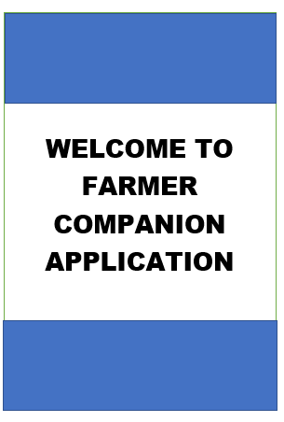

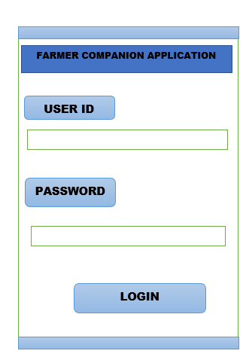

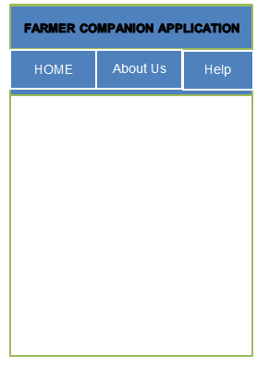

;

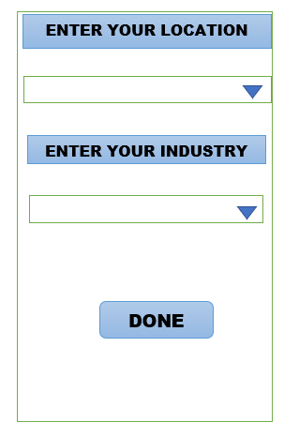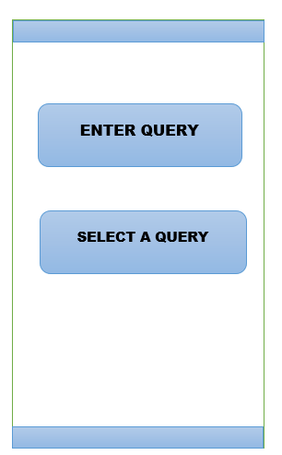

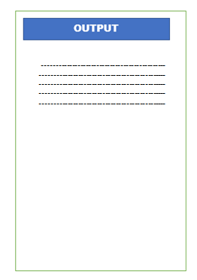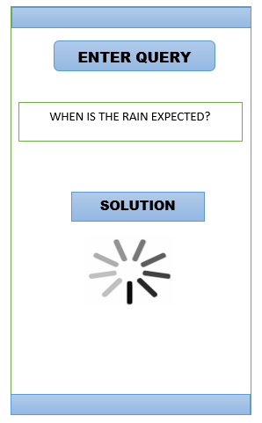

**Deliverables**

**Deliverable 1:**

* Project Proposal
* Project Overview

First deliverable will involve a brief introduction about our system. What it is? How it works?

**Deliverable 2:**

* SRS.tc.
* Literature Survey Report
* Analysis

Major deliverable of this phase will be Software Requirement Specification document (SRS) that will be generated after requirement gathering from our target user. It will be the extended brief version the proposal.

**Deliverable 3:**

* SDR

Software Design Report will be our third deliverable. After SRS, we will be focusing on the flow of our system. It will include tentative designing of interfaces, activity diagrams

**Deliverable 4:**

* System Prototype

After SDR, we will be coming towards the actual coding section. i.e implementation. This will generate a dummy mode that will be shown to our end user. This will be checked against SRS and will require user feedback.

**Deliverable 5:**

* SDT

We will be making series of tests against which we are going to test our system. It will be done by us.

At the end, test document will be generated containing test cases and results.

**Deliverable 6:**

* Complete system documentation

It will be the final report containing all deliverables report. It will include everything that is even a bit related to our software. From the point we started (planning) till how it looks in real, it will include everything. Moreover, depending on the time, we will be adding a user guide that will help narrative user to access it easily.

**Project Plan**

|  |  |  |  |  |
| --- | --- | --- | --- | --- |
| Task | Assigned To | Start | End | Days |
| Proposal Approval | Elad |  | 1/9/2018 |  |
| Choosing a DA | Elad |  | -- |  |
| Data Collection | Elad |  | -- |  |
| Project Specification and Design | Elad |  |  |  |
| Implementation | Elad |  |  |  |
| QA | DA |  |  |  |
| Evaluation | Elad |  |  |  |
| Write Up | Elad |  |  |  |